**Solution 3:**

**Step 1**: Create database: create database assignment

**Step 2** : Create table name Class : create table Class (EnrollmentNo int(4),StudentName varchar(255),Section varchar(2),SubjectId int(2),Marks int(3), primary key(EnrollmentNo));

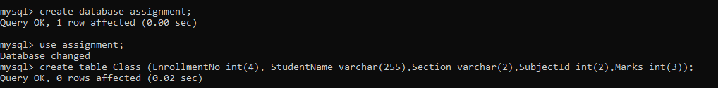

**Step 3**: Insert Data

Query : insert into Class values (1,'Tim','A',1,70),(2,'Jim','A',2,75),

(3,'Kim','B',3,65),(4,'Tom','B',4,77),(5,'John','C',5,60),(6,'Joe','C',1,82),

(7,'James','B',2,76),(8,'Henry','C',5,68),(9,'Matt','B',3,71),(10,'Paul','A',4,79);

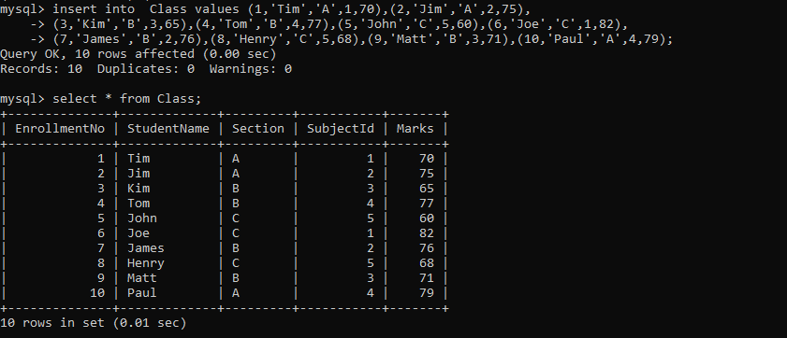

**Step 4:** Group Data on basis of section and condition on marks >=75

Query : select Section, count(Marks) as Number_of_candidates_greater_or_equal_75 from Class where Marks>=75 group by Section

